The Behavioral Approach
The Behavioral Approach brings psychological, social, and contextual explanations of human behavior to policy design and provides innovative, complementary and usually inexpensive solutions for policy improvement. The aim of the approach is to identify potential bottlenecks in existing systems and mechanisms of service delivery by giving emphasis to design details.

 | Traditional Approach | Behavioral Approach
What drives behavior? | Fixed preferences, values and monetary incentives | Context, variable preferences, values, costs and benefits
How is behavior changed? | Provide information and incentives | Remove barriers and create easier channels for decision and action
Reasons for inaction | Lack of value (preferences) or need for resources | Preferences, needs, context complexities or barriers
Approach to Poverty | Investigate deviations from assumptions or structural barriers | Investigate effect of poverty and context over decisions and actions
Adapted from Ideas42 (2015)

The approach follows a simple cycle of implementation:
- The first stage is to define the problem by identifying the stakeholders, their relevant behaviors, and the context.
- Then, the following stage is to diagnose the bottlenecks that prevent stakeholders from attaining the desired behavior. For this, the context is carefully examined to then provide hypothesis about which psychological concepts may cause the problem.
- Once potential bottlenecks and drivers have been identified, it comes the time to design interventions to address the challenge.
- In the implementation and evaluation stage, multiple interventions are carried out and assessed.
- Subsequently, after drawing lessons from the interventions comes a stage to adapt the initial assumptions. The problem statement, hypothesized bottlenecks, and

potential interventions are redefined, re-diagnosed, and redesigned until an effective intervention has been identified.

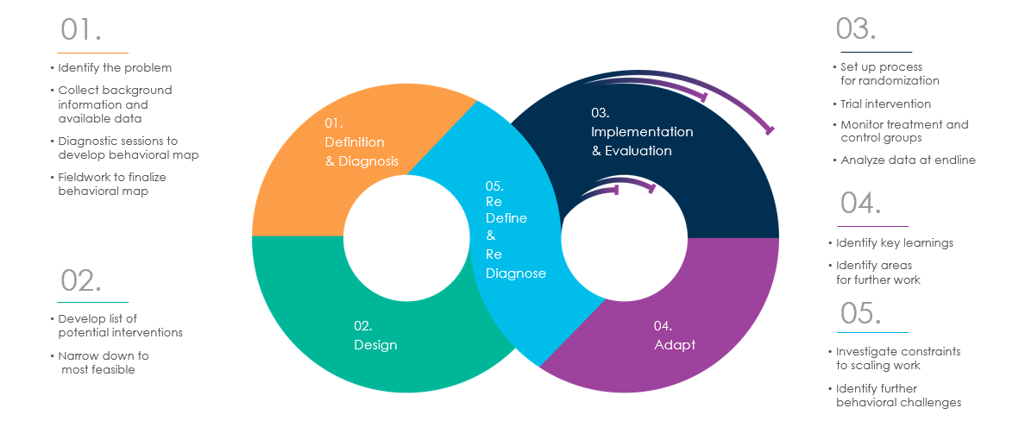
Under the iterative and adaptive process of the behavioral approach, the definition of problems, diagnosis of bottlenecks, and design of solutions become the fundamental stages to achieve an effective policy. Lastly, this is a learning process in itself, on that brings information, knowledge, experience, and most important, policy lessons.

Problem Definition

Defining a problem is a challenging task. Problems are multi-faceted and are caused by various factors that are usually intertwined. Furthermore, these root causes are often distorted and difficult to identify, because we tend to formulate problems in a way that subsumes our assumptions.
The elements of a clearly defined problem statement are the following:
- A stakeholder(s) or an identifiable actor(s) whose behavior we want to change,
- A well-defined behavior (or few key behaviors) that we are aiming to change in order to meet the desired outcome,
- A context and explicit assumptions that could bring further information on the bottlenecks that are preventing the desired behavior.

Some tactics and questions to ask when defining a problem in terms of a behavior are:

Change representation. The idea is to approach the problem from all the relevant stakeholders’ perspective and to assess it. In particular, is fundamental to think of the problem from the end user’s perspective and from those who interact or who influence decisions of the user.

- How do the stakeholders view this situation?
- Would they think there is a problem?
- How would they define it?

Change the scope. Problems too broadly defined could fall out of the reachable scope of the project, and those defined too narrowly could yield to irrelevant outcomes.

Zoom in:
- What are the components of the problem?
- Of these, what is the highest priority and achievable?

Zoom out:
- Is this part of another problem?
- Would fixing this problem just be one of many other fixes necessary to solve that other problem?

Remove assumptions. By asking “how” we could open up the range of possible solutions to try out.

- Instead of asking “Why is something happening?”,
- ask “How could that something happen?”

References
- Helpful Tactics to Define a Problem, The BETA Project, 2013
- Poverty Interrupted. Applying Behavioral Science to the Context of Chronic Scarcity, Ideas42, 2015.
- World Development Report 2015: Mind, Society, and Behavior, The World Bank, 2015.

