Behavioral Insights in Public Policy
1. Cognitive Biases that influence our decisions

While cognitive biases help us process information efficiently, they can lead to suboptimal decision making. Here are the most common ones.
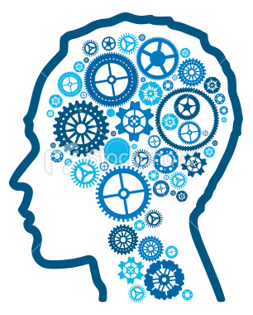
Anchoring
Is the tendency to rely too heavily, or "anchor," on one trait or piece of information when making decisions.

Availability
To overestimate the importance of information that is available. We tend to let an example that easily come to mind affect our decision-making or reasoning.

Blindspot
People tend to believe their own judgments are more objective and less susceptible to biases than the judgments of other people.
Source markdeanwealthmanagement.com

Confirmation
When someone looks for and interprets new evidence as confirmation of his or her existing beliefs or theories.

Gambler’s Fallacy
The tendency to think that future possible outcomes are altered by past events, when they are unchanged. For example, "I've flipped heads with this coin five times consecutively, so the chance of tails coming out on the sixth flip is much greater than heads.”

Hyperbolic Discounting
The tendency to have a stronger preference for more immediate payoffs than for later ones. Hyperbolic discounting leads to choices that are inconsistent over time: people make choices today that their future selves would prefer not to have made, despite using the same reasoning.

Loss Aversion
We usually prefer avoiding losses to acquiring gains. Most studies demonstrate that losses are twice as powerful, psychologically, as gains.
Planning Fallacy
Is the propensity to underestimate the duration that is needed to complete a task.

Overconfidence
When an individual’s subjective confidence in his or her judgments is greater than the objective accuracy of those judgments, especially when confidence is relatively high.

Status quo
When an individual has a preference for the current state of affairs and a change from it is perceived as a loss.

Sunk cost fallacy
Our decisions are tainted by the emotional investments we accumulate and the more we invest in something the harder it becomes to abandon it.

References
- The Psychology of Judgment and Decision Making (McGraw-Hill Series in Social Psychology), Scott Plout, 1993
- Judgment in Managerial Decision Making, Max Bazerman, 2012
2. Group Biases that influence our decisions
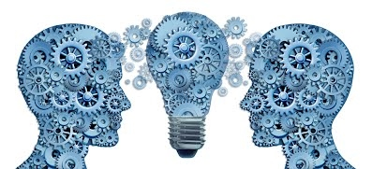
Source neojungiantypology.com
Social and group biases refer to systematic errors individuals make when trying to find reasons for their own and others’ behaviors. Rather than operating as objective perceivers, people are prone to perceptual errors that lead to biased interpretations of their social world.

Bandwagon effect
When people do something primarily because other people are doing it, regardless of their own beliefs, which they may ignore or override.

Group attribution error
When we believe that individuals in the group agree with the decision of the group, by following group rules instead of their own preferences.

Halo effect
When the overall impression of a person influences the observer's feelings and thoughts about that person

References
- Human inference: Strategies and shortcomings of social judgment. Nisbett,& Ross, 1980.
- Judgment in Managerial Decision Making, Max Bazerman, 2012

